**Project 5- Introduction To LCD (Liquid Crystal Display)**

The LiquidCrystal library allows you to control LCD displays that are compatible with the Hitachi HD44780 driver. There are many of them out there, and you can usually tell them by the 16-pin interface.

The LCDs have a parallel interface, meaning that the microcontroller has to manipulate several interface pins at once to control the display.

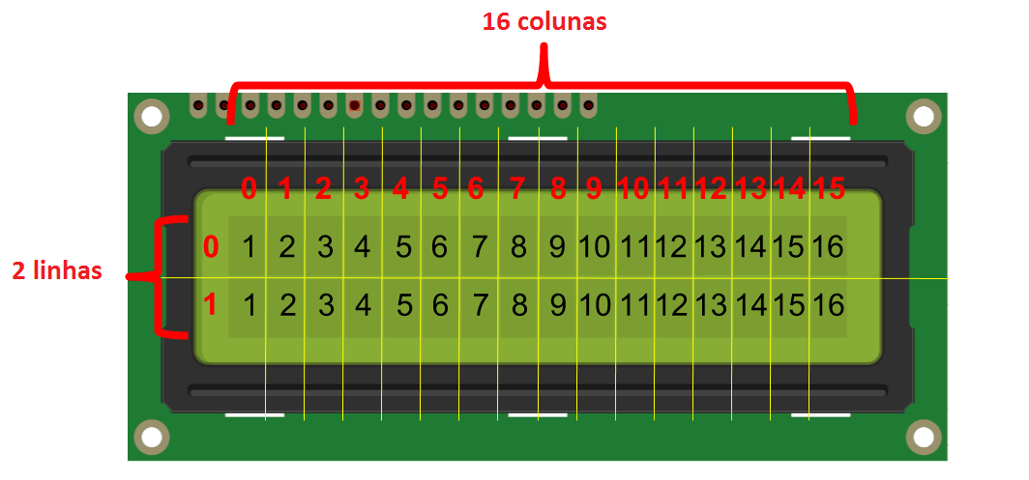

The interface consists of the following pins:

A **register select (RS) pin** that controls where in the LCD's memory you're writing data to. You can select either the data register, which holds what goes on the screen, or an instruction register, which is where the LCD's controller looks for instructions on what to do next.

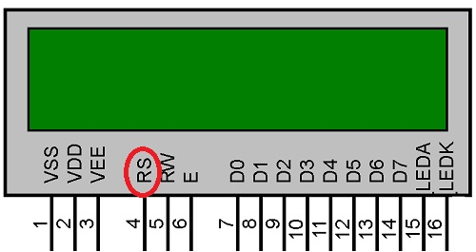

The interface consists of the following pins:

A **Read/Write (R/W) pin** that selects reading mode or writing mode

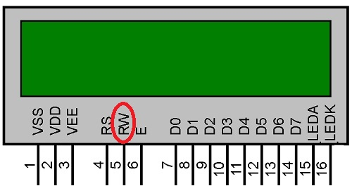

The interface consists of the following pins:

An **Enable pin** that enables writing to the registers

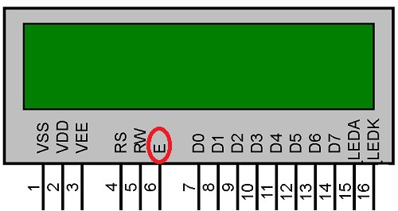

The interface consists of the following pins:

8 **data pins (D0 -D7)**. The states of these pins (high or low) are the bits that you're writing to a register when you write, or the values you're reading when you read

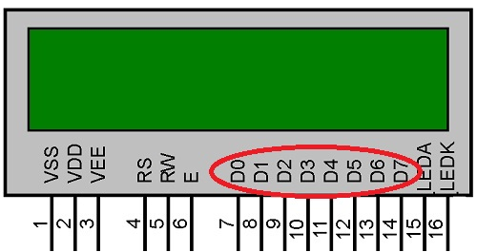

The interface consists of the following pins:

There's also a **display contrast pin (Vo)**, **power supply pins (+5V and Gnd)** and **LED Backlight (Bklt+ and BKlt-)** pins that you can use to power the LCD, control the display contrast, and turn on and off the LED backlight, respectively.

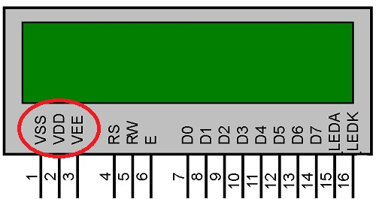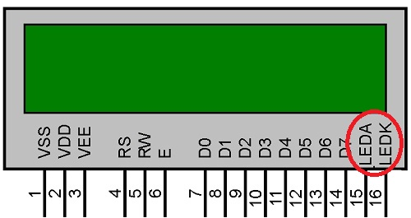

* The process of controlling the display involves putting the data that form the image of what you want to display into the data registers, then putting instructions in the instruction register. The **LiquidCrystal Library simplifies** this for you so you don't need to know the low-level instructions.
* The Hitachi-compatible LCDs can be controlled in two modes: 4-bit or 8-bit. The 4-bit mode requires seven I/O pins from the Arduino, while the 8-bit mode requires 11 pins. For displaying text on the screen, you can do most everything in 4-bit mode, so example shows how to control a 2x16 LCD in 4-bit mode.

***Now Try to Write Robotry Bangladesh in 16x2 LCD***

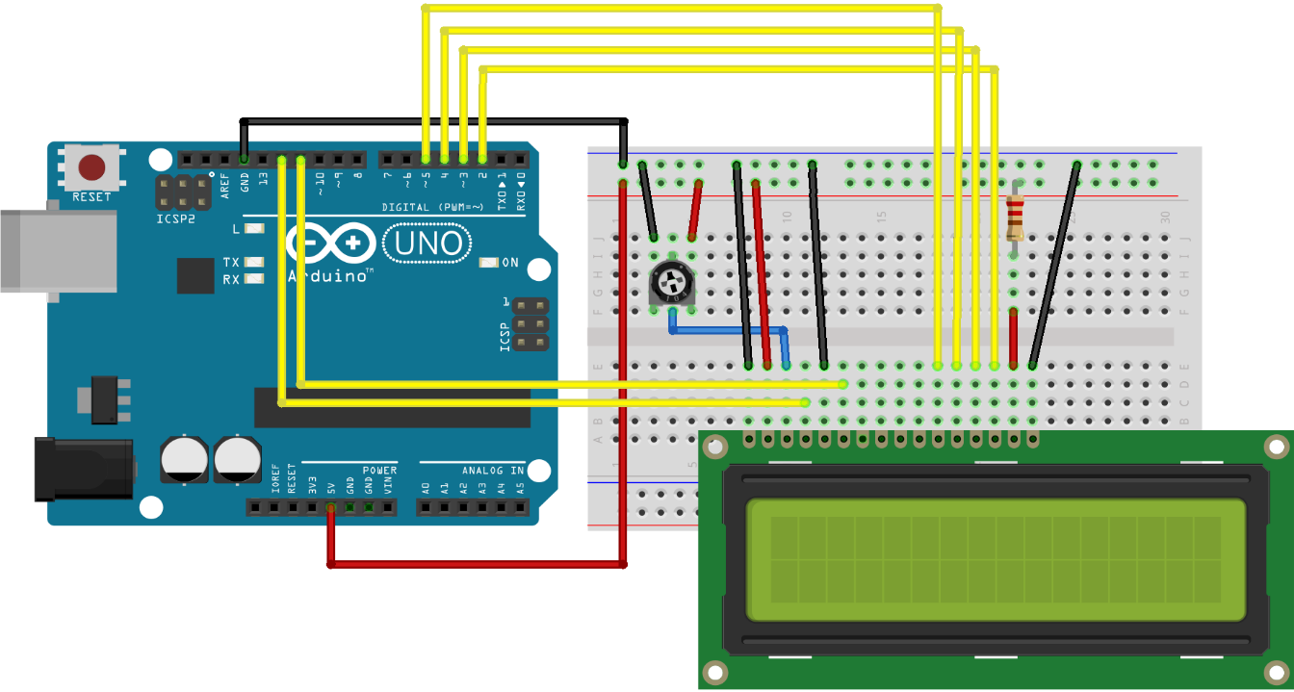

***This sketch prints "Robotry BD!" to the LCD and shows the time of being displayed, Starting from Zero (0).***

**Hardware Required:**

* Arduino or Genuino Board
* LCD Screen
* pin headers to solder to the LCD display pins
* 10k ohm potentiometer
* 220 ohm resistor
* Jumper Wires
* breadboard

For Code, Please Scan the QR CODE: